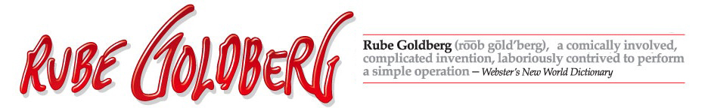Rube Goldberg (1883-1970) was a Pulitzer Prize winning cartoonist, sculptor and author. Best known for his “inventions”, Rube’s early years as an engineer informed his work. A Rube Goldberg contraption – an elaborate set of arms, wheels, gears, handles, cups and rods, put in motion by balls, canary cages, pails, boots, bathtubs, paddles and live animals – takes a simple task and makes it extraordinarily complicated. He had solutions for How To Get The Cotton Out Of An Aspirin Bottle, imagined a Self-Operating Napkin, and created a Simple Alarm Clock – to name just a few of his hilariously depicted drawings. Rube did not build the machines he drew, but his cartoons have become an inspiration to aspiring engineers and scientists across the world.
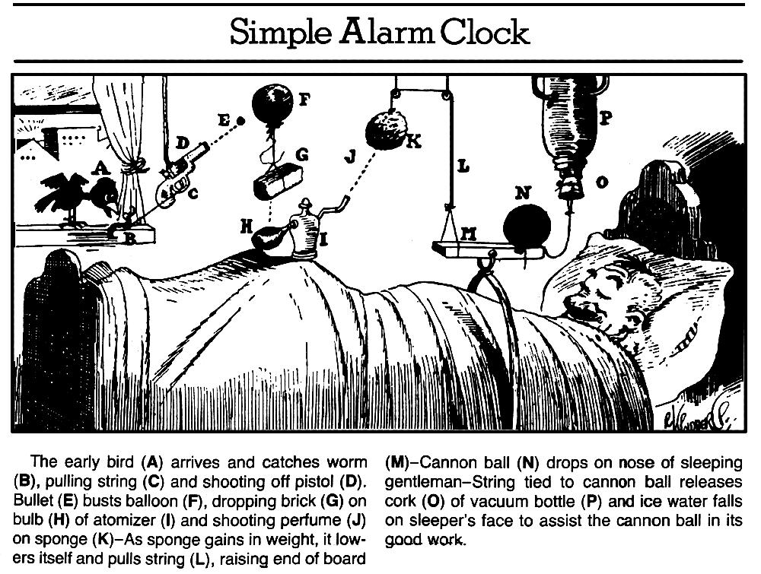
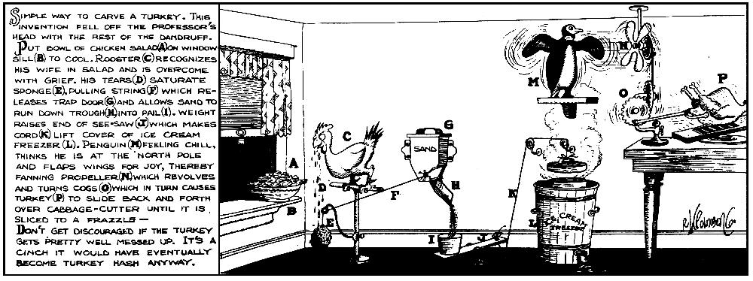

FOLLOWING IN THE FOOTSTEPS OF RUBE GOLDBERG
Your Task:
You will design your OWN “Rube Goldberg Machine” on paper incorporating ALL SIX of the simple machines we have studied in class. You may use any combination that you would like, and you may use each machine more than once as long as all machines are represented in your cartoon. In your cartoon, your machine must complete a task of your choice.
Some tasks to consider might be:

- Pop a balloon
- Water a plant
- Zip a zipper
- Crack an egg
- Turn on a radio
- Sharpen a pencil
- Put toothpaste on a toothbrush
- Hammer a nail
- Butter a piece of bread

You may also design a machine for a task that is not listed here. Please do not make the machine you design! You are only required to turn in a full color illustration of your design with an accompanying paragraph to explain how your machine works. Please see the illustrations on the other side of this sheet for help.
Due Date and Points:
The completed cartoon is due Thursday, November 20th. This mini-project is worth 50 points.
Rubric for this Project
Student has included all SIX simple machines in a way that makes sense for the function of that machine. (This means that a wedge should be used as a wedge, possibly to cut something. Another example is that a wheel is used to roll something, not just placed in the picture without a purpose) | 12 points
Student has completed a simple task using machine. | 10 points
Student has written a paragraph that clearly explains step by step how the machine works to accomplish the task. | 10 points
Student has used crayons, colored pencils, or other appropriate tools to create a full-color illustration of their machine. | 8 points
Student has created a clever name for their machine | 5 points
Student has completed work on a white sheet of copy paper, and it represents their BEST handwriting and explanation effort. | 5 points
 | Total for Project: 50 Points
BONUS CHALLENGE: Student has incorporated ALL of the following items into their machine: a live animal your choice, a bucket, a piece of string | 10 points

