

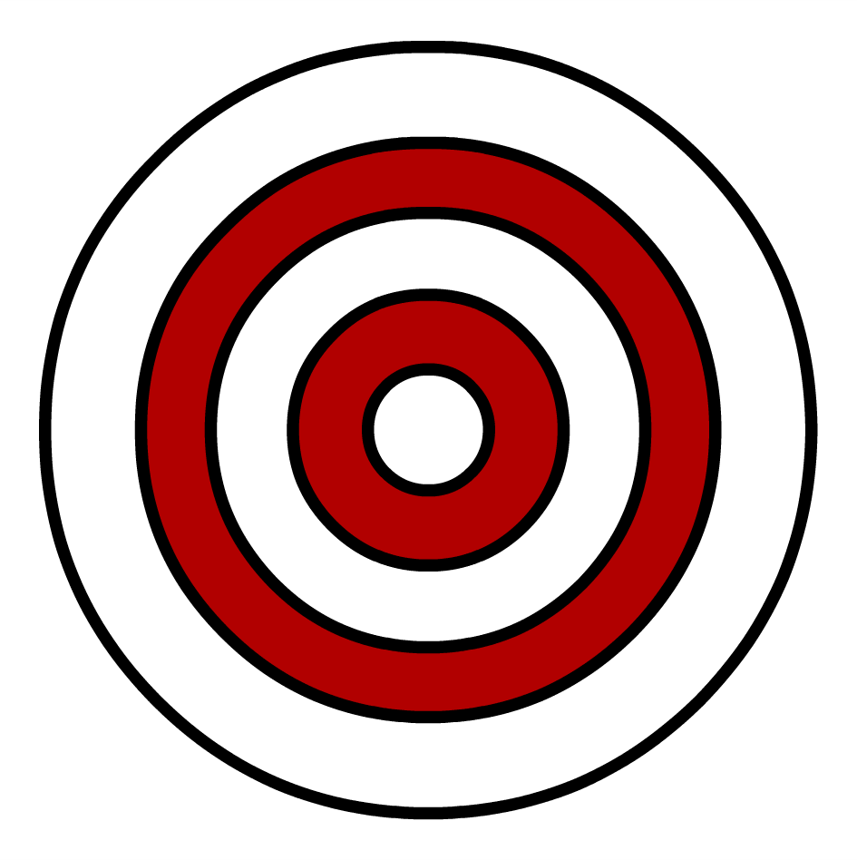

Precision vs. Accuracy

What is “precision”?

What is “accuracy”?







Precision vs. Accuracy

What is “precision”?

What is “accuracy”?



